parking slot managment
TEAM - B

Parking Slot Management System

Parking Management Slot System:
The Parking Management Slot System is designed to efficiently manage vehicle parking by automating slot allocation, entry/exit tracking, and billing. For example, in places like malls or apartment parking, instead of manually checking for space, the system automatically assigns an available slot and calculates the parking fee when the vehicle exits. This reduces manual effort, avoids confusion, and ensures better space utilization.

Objectives
- To automate the process of parking slot allocation for vehicles
- To reduce manual effort and human errors in managing parking
- To efficiently track vehicle entry and exit times
- To calculate parking fees accurately based on duration
- To improve overall parking space utilization and management

System Overview
The Parking Management Slot System is designed to manage vehicle parking in an organized and automated way. When a vehicle enters, the system records its details and assigns an available parking slot. It continuously tracks the parking duration and, upon exit, calculates the total fee based on the time spent. The system also updates slot availability in real-time, ensuring efficient use of parking space and smooth operation.

Modules / Features
The system is divided into the following modules:
- Vehicle Entry Module
- Slot Allocation Module
- Exit Module
- Billing Module
- Reports Module

1. Vehicle Entry Module
This module is responsible for recording the details of the vehicle when it enters the parking area. It stores information such as vehicle number and entry time in the system.
2. Slot Allocation Module
This module assigns an available parking slot to the incoming vehicle. It ensures that slots are allocated efficiently and avoids duplication or overbooking.
3. Exit Module
This module handles the vehicle exit process. It records the exit time and calculates the total duration the vehicle stayed in the parking area.
4. Billing Module
This module calculates the parking fee based on the duration of stay. It may also include additional charges like late fees and generates the final bill.
5. Reports Module
This module provides useful information such as total number of vehicles parked, available slots, and total revenue collected. It helps in monitoring and analysis.

Working Process (System Flow):
The working of the Parking Management System follows these steps:
- The vehicle enters the parking area
- The system records the vehicle number and entry time
- An available parking slot is assigned to the vehicle
- The vehicle is parked in the allocated slot
- When the vehicle exits, the system records the exit time
- The total parking duration is calculated
- The parking fee is calculated based on the duration
- The final bill is generated and displayed

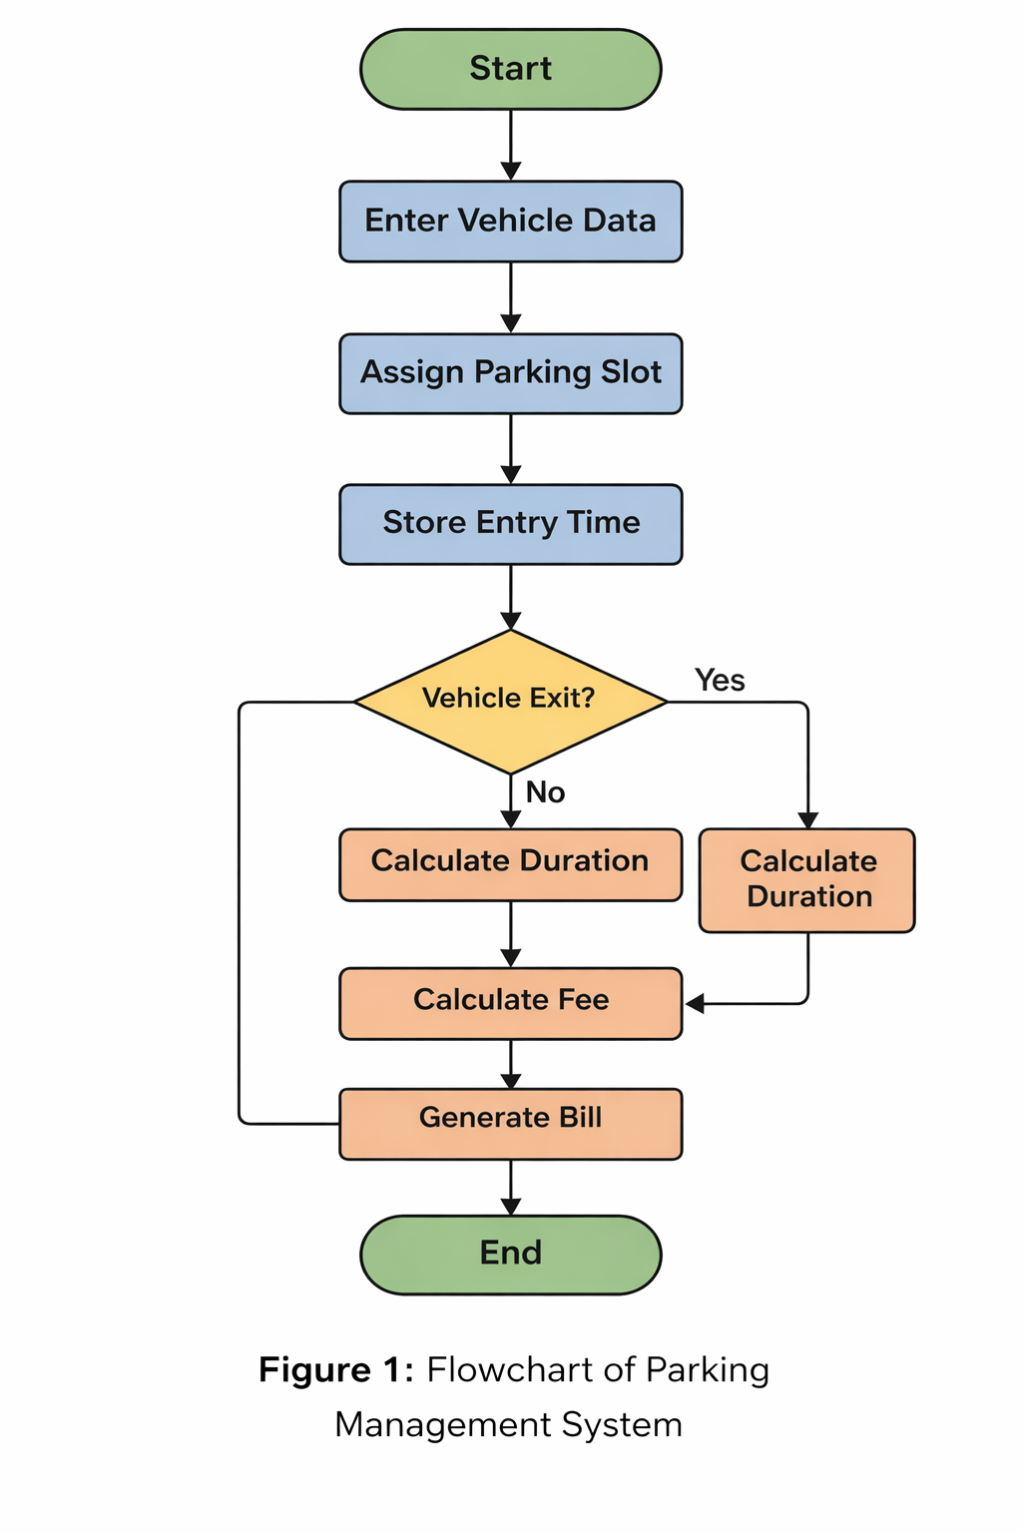
Flowchart of Parking Management System:

System Design (Database Design):
The Parking Management System uses a relational database named "parking_management" to store and manage data efficiently. And multiple tables to store the records.
The following tables are used in the system:
- Vehicle Records Table
- Parking Slots Table
- Fee Table
- Payment Records Table

Vehicle Records Table:
This table is the core of the system and stores all vehicle entry and exit details. It helps in tracking parking duration, calculating fees, and managing payment status. Each record represents a single parking instance.

Column Name | Data Type | Description
record_id | INT | Unique ID for each vehicle record
vehicle_number | VARCHAR | Vehicle number
owner_name | VARCHAR | Owner of the vehicle
vehicle_type | VARCHAR | Type (Car/Bike)
slot_id | INT | Assigned parking slot
entry_time | DATETIME | Vehicle entry time
exit_time | DATETIME | Vehicle exit time
parking_hours | FLOAT | Total parking duration
parking_fee | FLOAT | Calculated parking fee
late_fee | FLOAT | Extra charge if applicable
payment_stats | VARCHAR | Payment status (Pending/Paid)

Parking Slots Table
This table maintains information about all available parking slots. It helps in assigning slots to vehicles and tracking their availability in real-time.

Column Name | Data Type | Description
slot_id | INT | Unique slot number
slot_type | VARCHAR | Type (Car/Bike)
floor_number | INT | Floor location
is_available | BOOLEAN | Slot availability (1 = Yes, 0 = No)

Fee Table
This table defines the parking fee structure based on vehicle type. It is used to calculate the total parking fee depending on the duration of parking.
Column Name | Data Type | Description
vehicle_type | VARCHAR | Type of vehicle
rate_per_hour | FLOAT | Parking charge per hour

Payment Records Table
This table stores all payment-related transactions. It helps in tracking completed payments and linking them with vehicle records for financial management.

Column Name | Data Type | Description
payment_id | INT | Unique payment ID
record_id | INT | Reference to vehicle record
amount_paid | FLOAT | Total amount paid
payment_time | DATETIME | Time of payment

Database Design and Implementation:

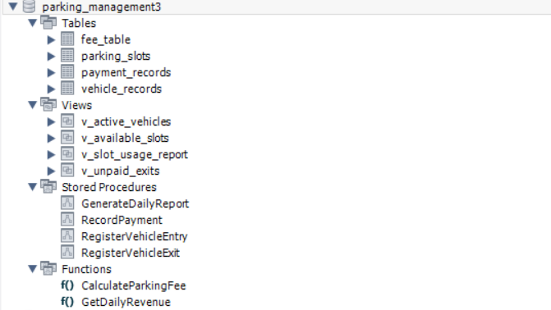

1. Views:
Views are virtual tables created using SQL queries to simplify data access and improve readability.
- v_active_vehicles → Shows currently parked vehicles
- v_available_slots → Displays free parking slots
- v_slot_usage_report → Shows slot usage statistics
- v_unpaid_exits → Lists vehicles with pending payments

2. Stored Procedures:
Stored Procedures are pre-defined SQL programs stored in the database to perform specific operations efficiently.
- RegisterVehicleEntry → Records vehicle entry
- RegisterVehicleExit → Handles exit and updates details
- RecordPayment → Stores payment transaction
- GenerateDailyReport → Generates daily parking report

3. Functions:
Functions are reusable SQL blocks that return a value after performing calculations.
- CalculateParkingFee → Calculates fee based on duration
- GetDailyRevenue → Returns total daily earnings

Er diagram:
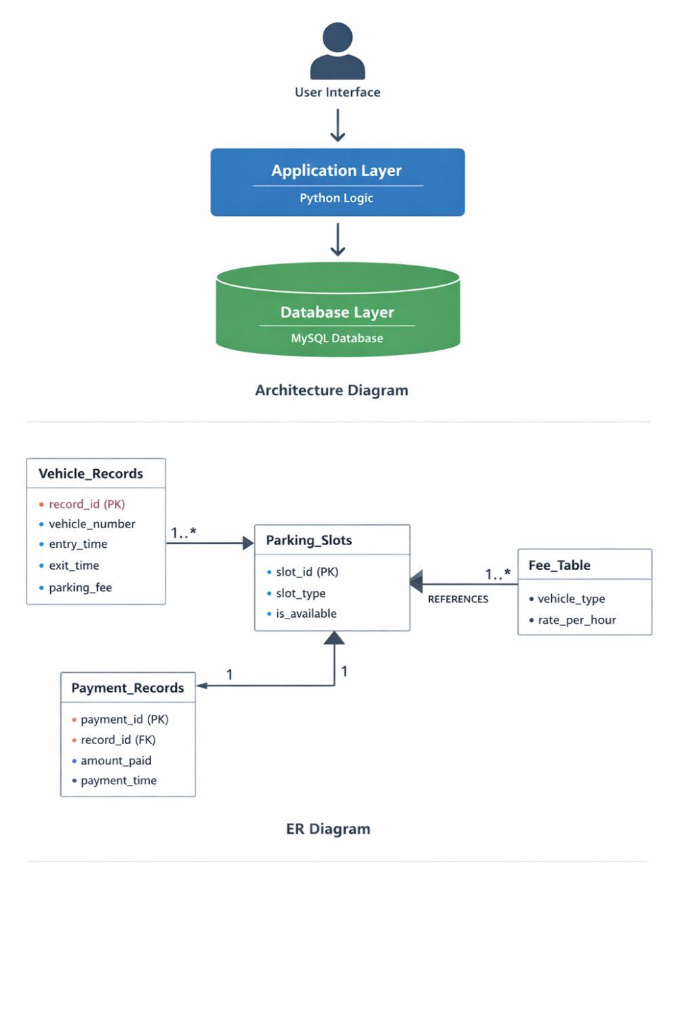

The Entity-Relationship (ER) Diagram represents the structure of the database and illustrates how different entities in the Parking Management System are related to each other. It provides a clear understanding of data organization, relationships, and flow within the system.
The system consists of four main entities: Vehicle Records, Parking Slots, Fee Table, and Payment Records.

1. Vehicle Records:
The Vehicle Records table is the core entity of the system. It stores all details related to vehicle entry and exit, including vehicle number, entry time, exit time, parking duration, and parking fee. Each record represents a single parking instance and is uniquely identified by the primary key record_id.

2. Parking Slots:
The Parking Slots table contains information about all available parking slots. It includes details such as slot ID, slot type, and availability status. This table helps in assigning slots efficiently and tracking their usage in real time.

Relationship: Vehicle Records → Parking Slots
There is a one-to-many relationship between Parking Slots and Vehicle Records. A single parking slot can be used by multiple vehicles over time, but each vehicle record is associated with only one slot at a given time.

3. Fee Table:
The Fee Table defines the parking charges based on the type of vehicle. It includes attributes such as vehicle type and rate per hour. This table is used to calculate the parking fee for each vehicle based on its duration of stay.

Relationship: Parking Slots → Fee Table:
There is a one-to-many relationship between the Fee Table and Parking Slots. A single fee structure (for example, car or bike) can be applied to multiple parking slots.

4. Payment Records:
The Payment Records table stores all payment-related information. It includes details such as payment ID, record ID (foreign key), amount paid, and payment time. This table ensures proper tracking of financial transactions.

Relationship: Vehicle Records → Payment Records:
There is a one-to-one relationship between Vehicle Records and Payment Records. Each vehicle record is associated with one payment, and each payment corresponds to a single vehicle record.

System Flow:
When a vehicle enters the parking area, its details are stored in the Vehicle Records table and a parking slot is assigned. The parking fee is calculated using the Fee Table based on the duration of stay. Upon exit, the payment is recorded in the Payment Records table, completing the parking process.

Outputs:

View_slots:
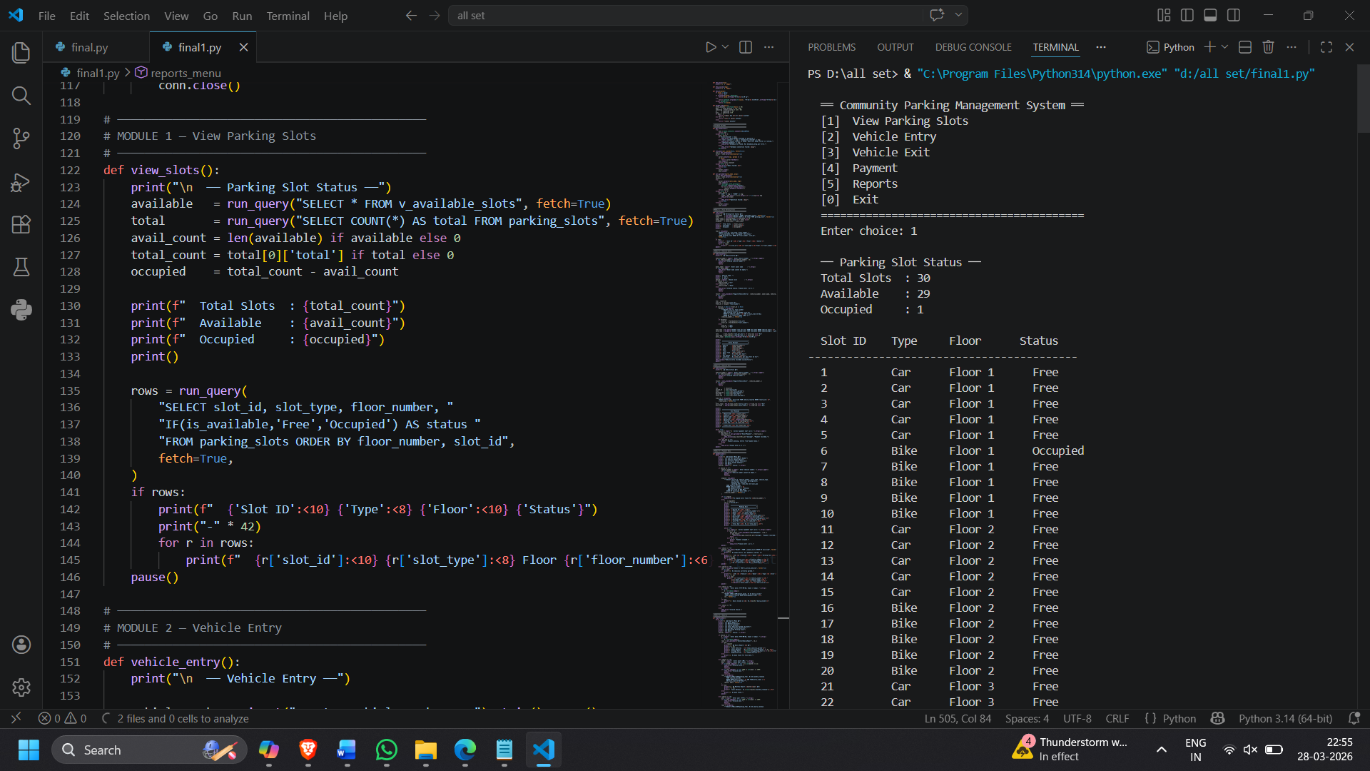

Vechile_Entry:
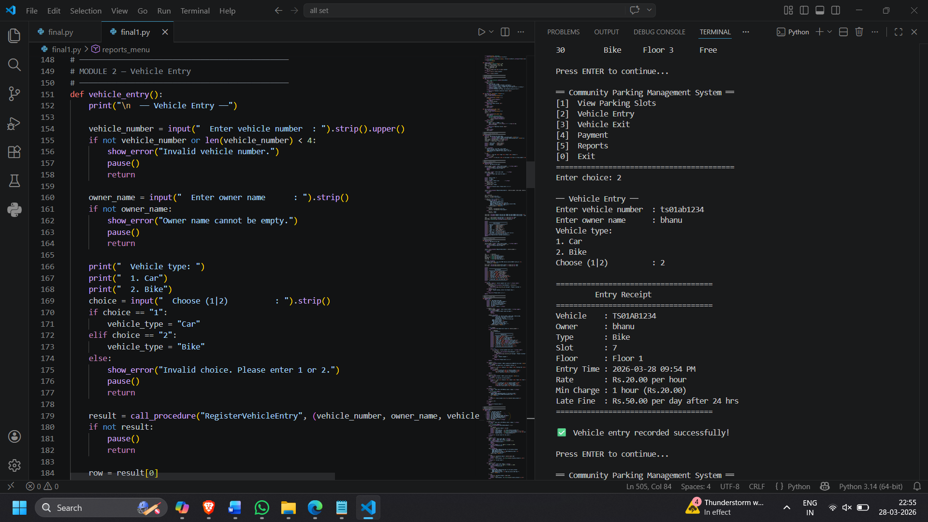

Vechile_Exit:
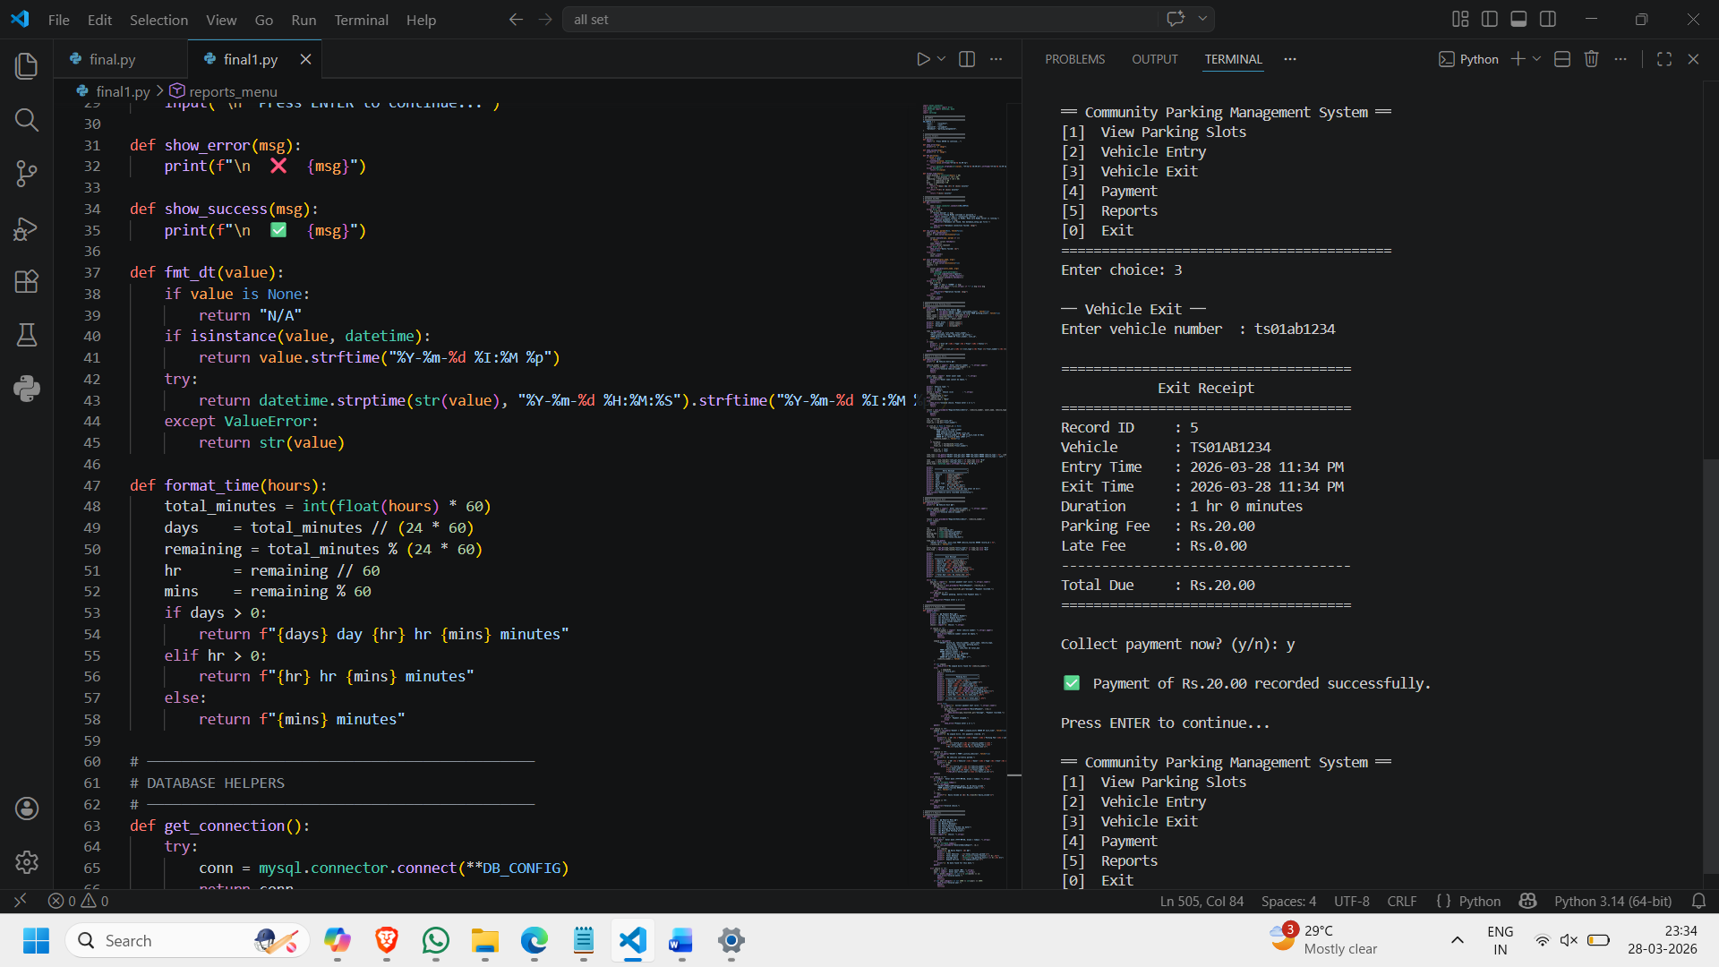

Pay_by-vehicle_number:

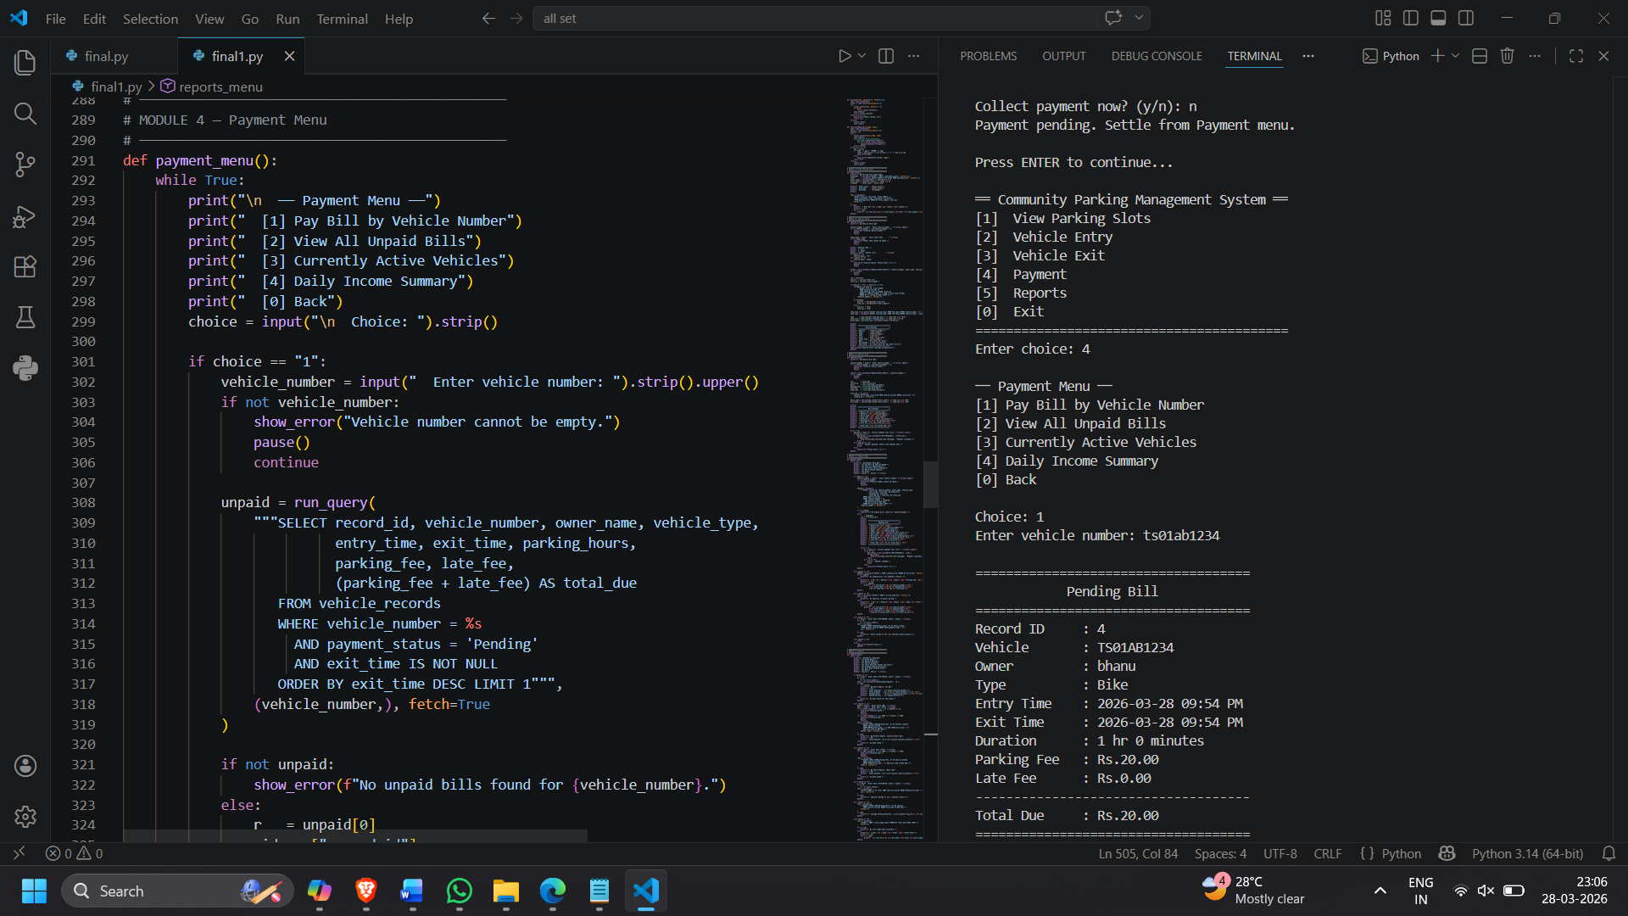

Unpaid_bills:

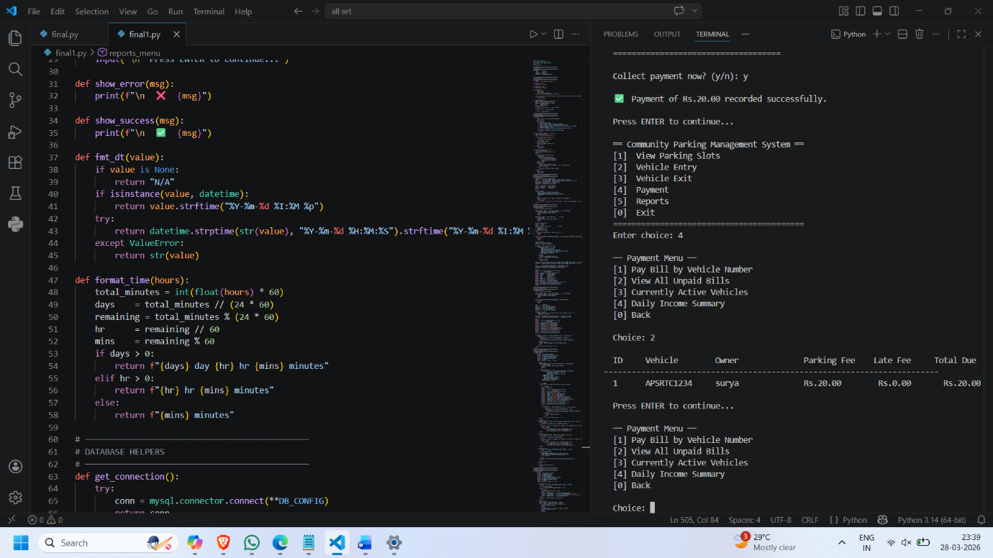

Current_Active_Vehicles:

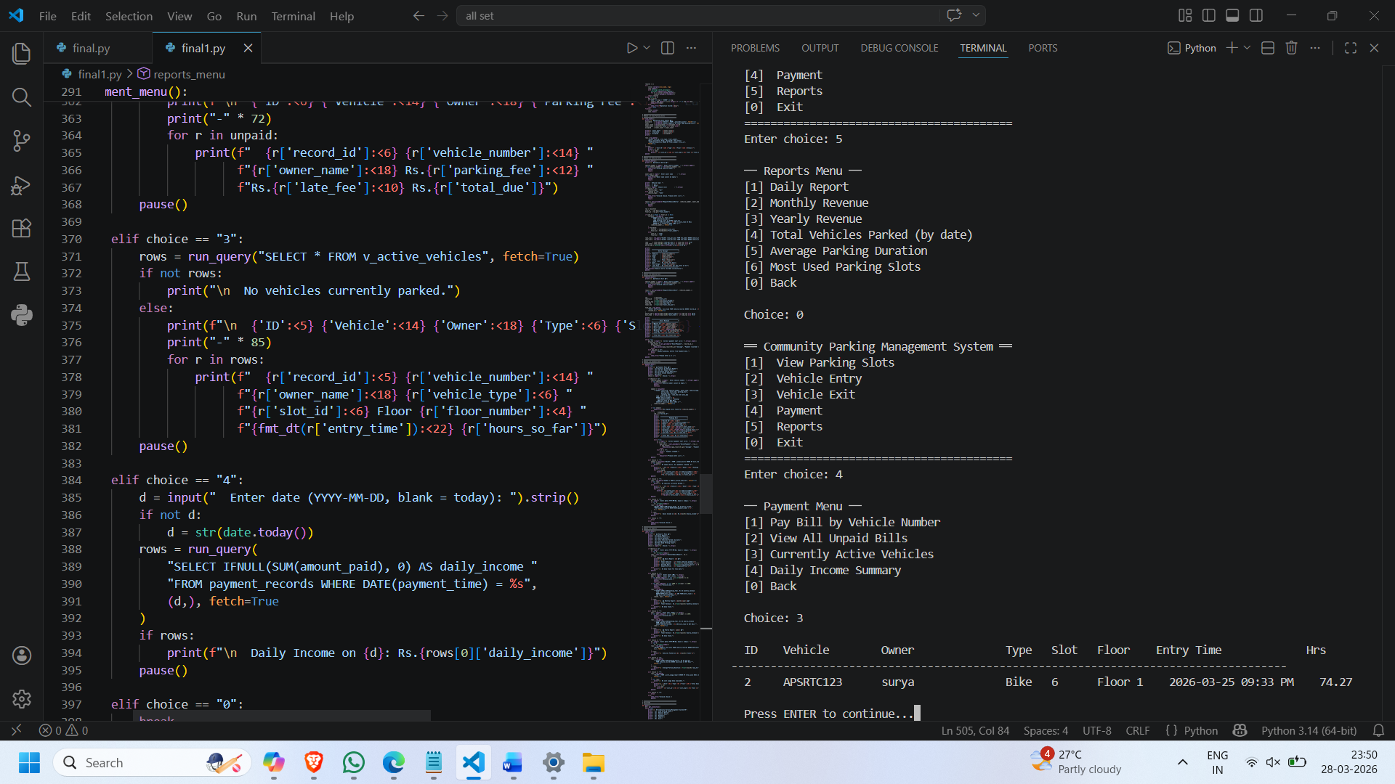

Daily Income:

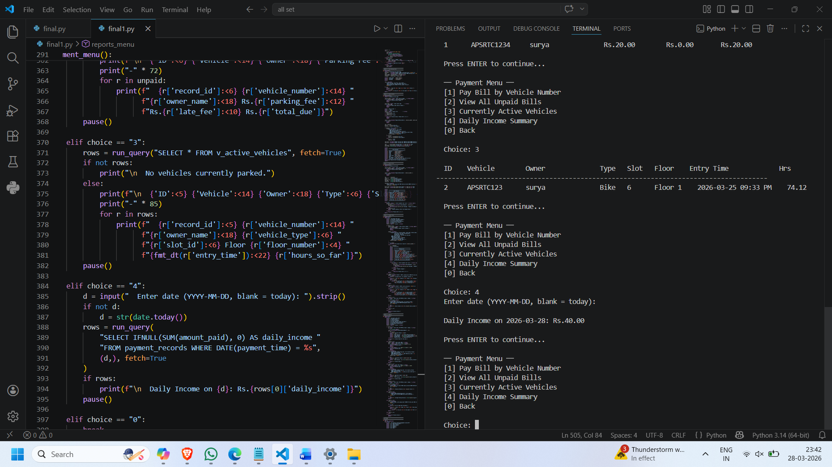

Daily_Report:

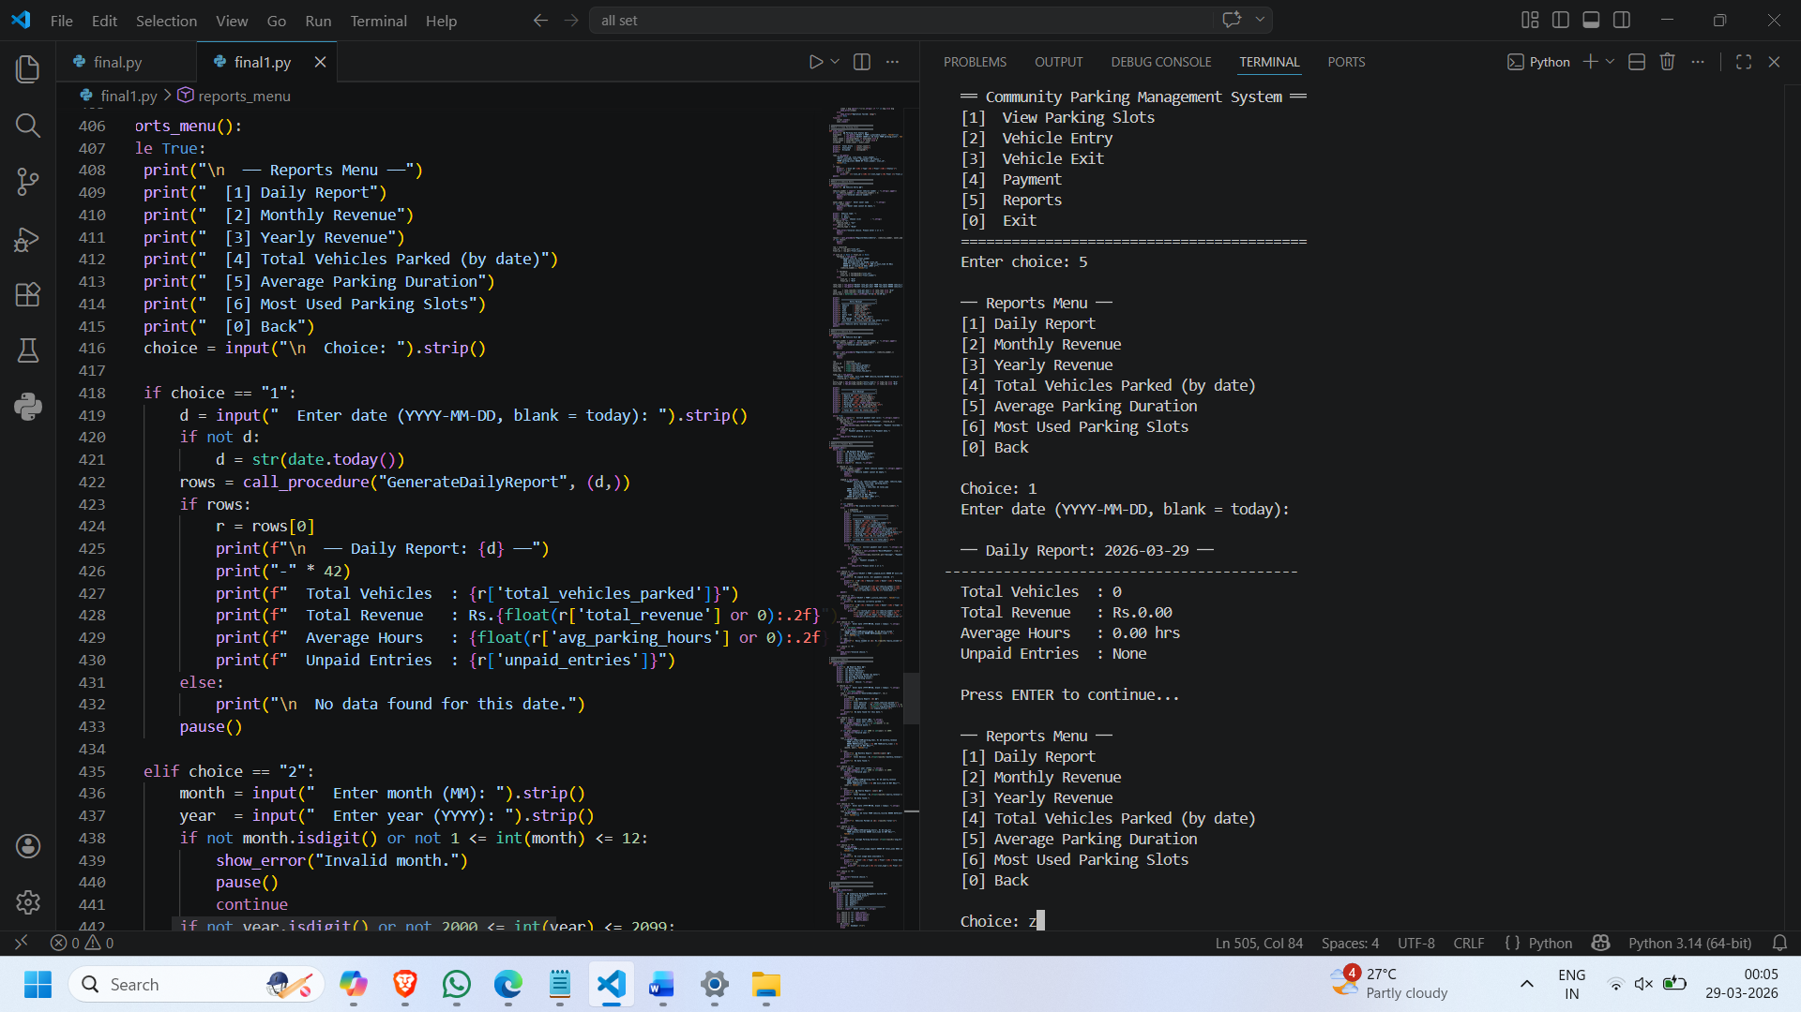

Monthly_Revenue:

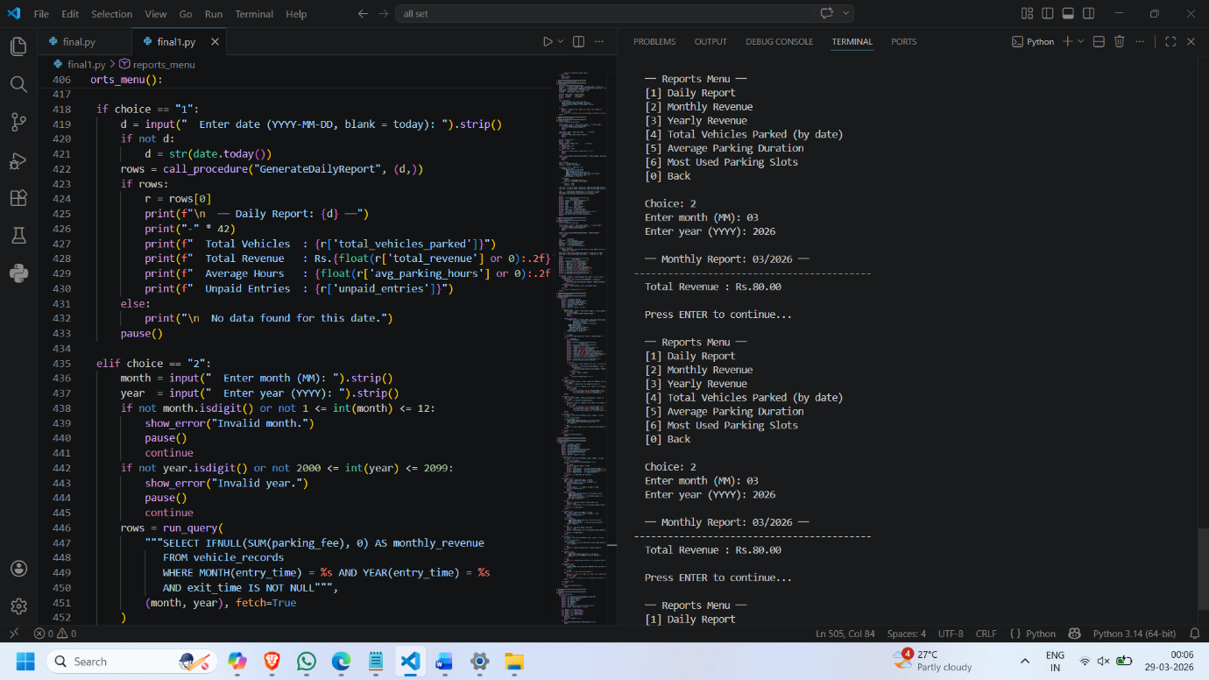

Yearly_Revenue:

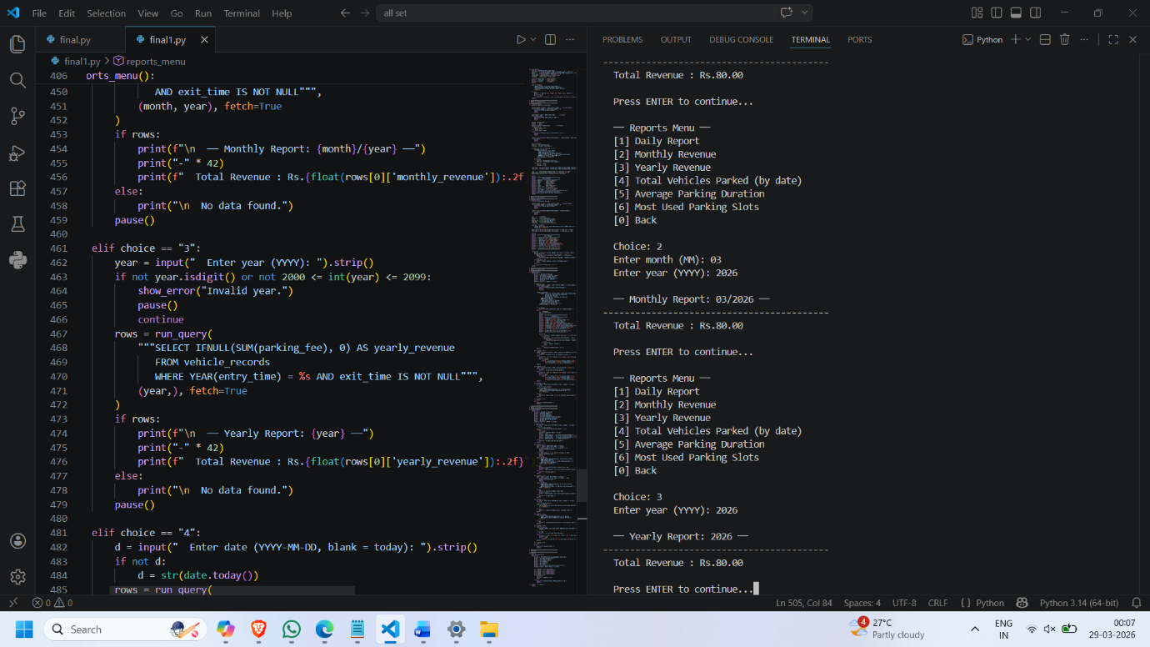

Total_Vehicles_Parked:

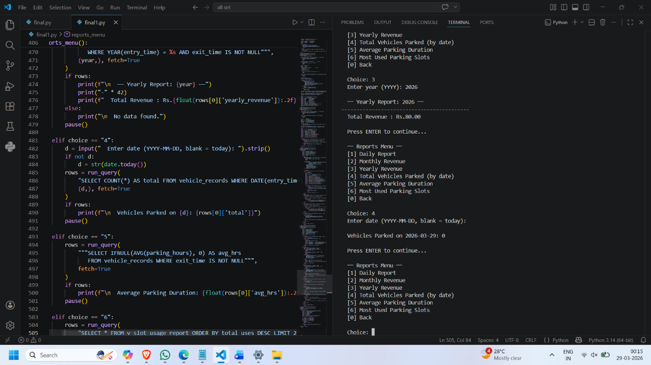

Average_Parking_Duration:
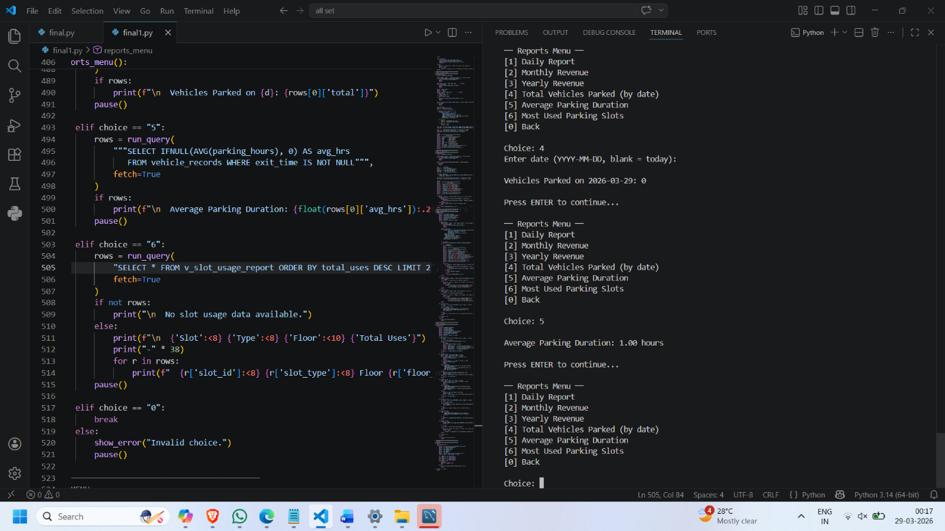

Most_Used_Slots:
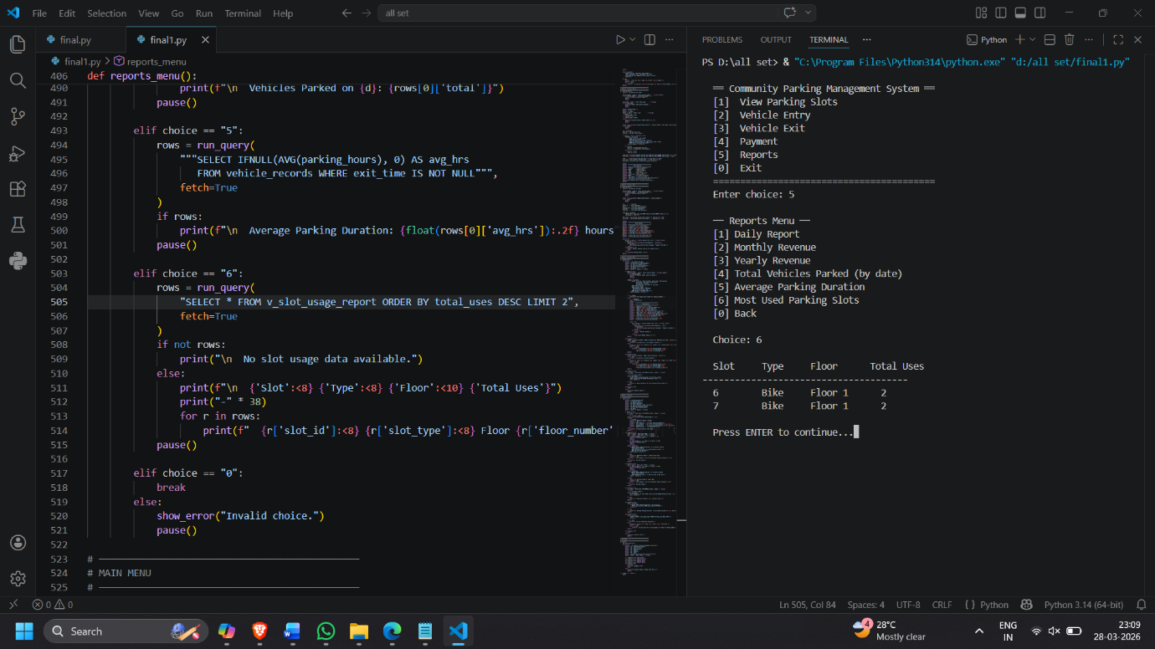

Technologies Used
- Programming Language: Python
- Database: MySQL
- Tool: MySQL Workbench

Future Enhancements:
• Integration with mobile app
• Online slot booking system
• QR code-based entry/exit
• Real-time dashboard using Power BI
• Payment integration (UPI/Card)
Conclusion
The Parking Management Slot System successfully automates the process of vehicle parking, reducing manual effort and improving efficiency. It ensures proper slot allocation, accurate billing, and better management of parking resources.

